Grade 2
Year 2
Workbook

Index
Week 1-2: Water
Week 3, 4 &5: Our country South Africa
Week 6-7: Communication in our world
Week 8-9: Life at night

Theme: water

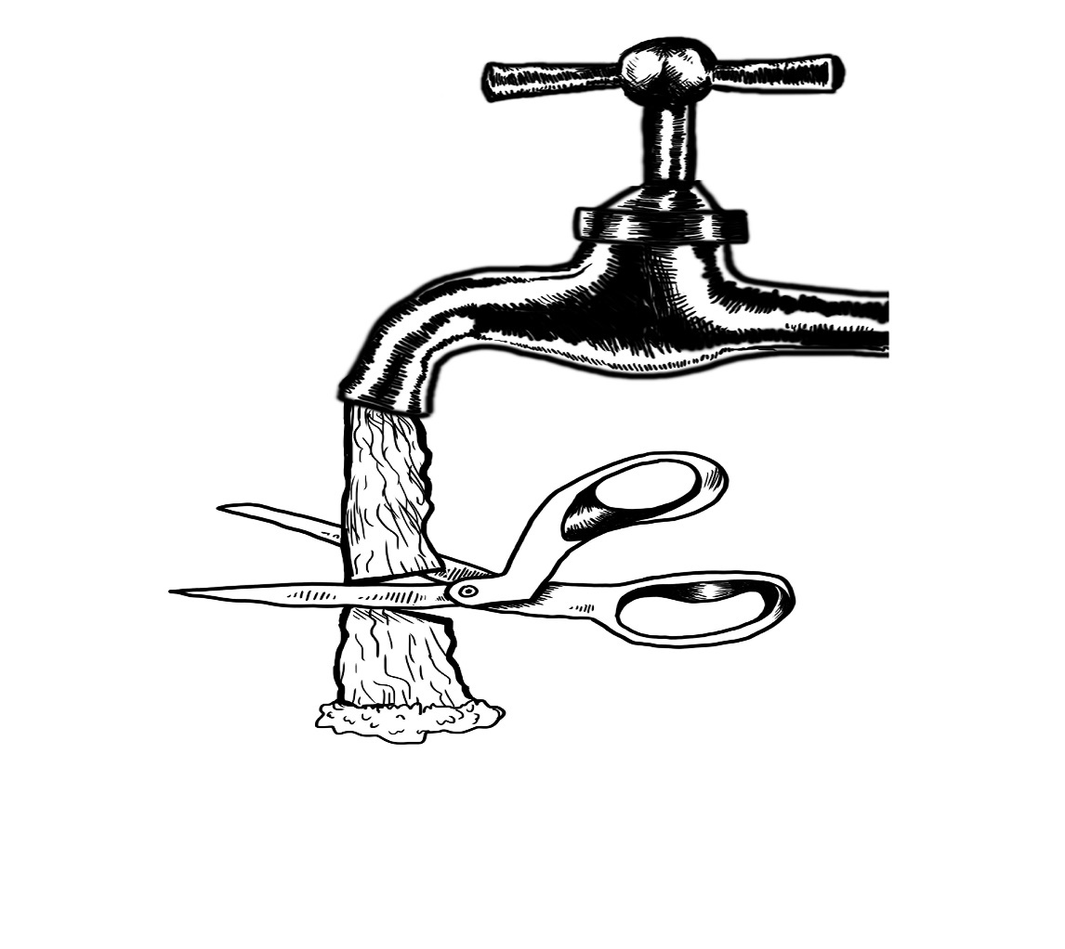
Introduction

Group 1


Colour the water bottle using pencil colours
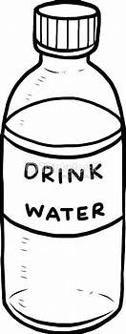

Practical task

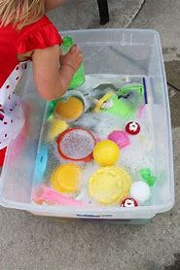

Colour in the picture below

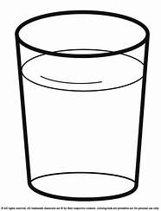

Group 2

Water cycle
Colour in the water cycle

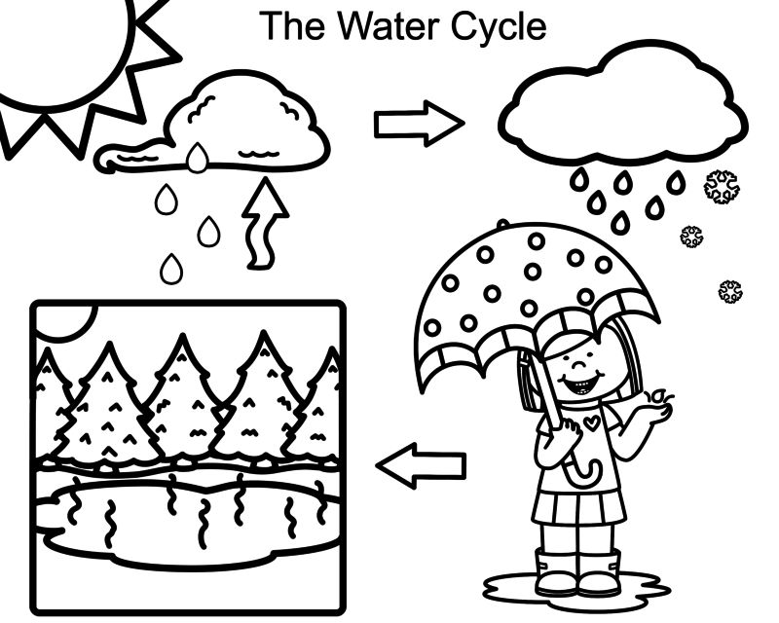

Fill in the water cyle using the following words
condensation | precipitation | Collection | Exploration

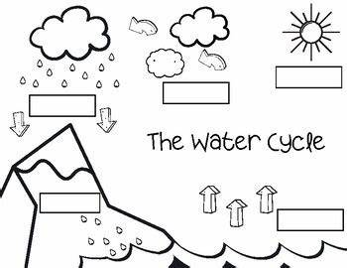

Colour the picture below


Group 3

Answer the following questions given in the worksheet on water and its uses:
- Why do we not drink sea water?
______________________________________________________________________________________________________________________________
- Name three things for which you use water.
______________________________________________________________________________________________________________________________
- How can we kill germs in our drinking water?
______________________________________________________________________________________________________________________________
- What is one way in which people pollute water?
______________________________________________________________________________________________________________________________
- Name the three forms of water.
______________________________________________________________________________________________________________________________

Fill in the blanks using the words below
thirsty | fire | electricity | water | bath
water | needs | Food | water | Baoting

1. Water is also one of basic ________.
2. Plants need water to prepare their ________.
3. We do ________ in water.
4. Animals take a _____________ in the water of rivers, ponds or lakes.
5. we use __________for cooking and washing
6. You drink water when you are ___________.
7. Water is needed for putting-off ___________.
8. Plants need ___________ for germination.
9. You should not waste ____________.

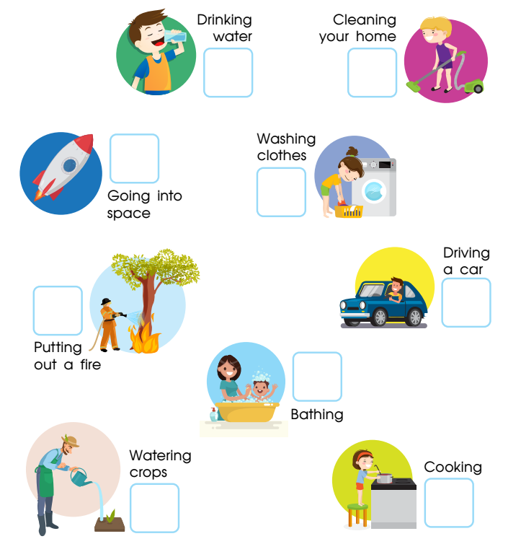

What are the 3 ways you can save water?
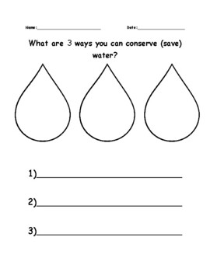

Theme
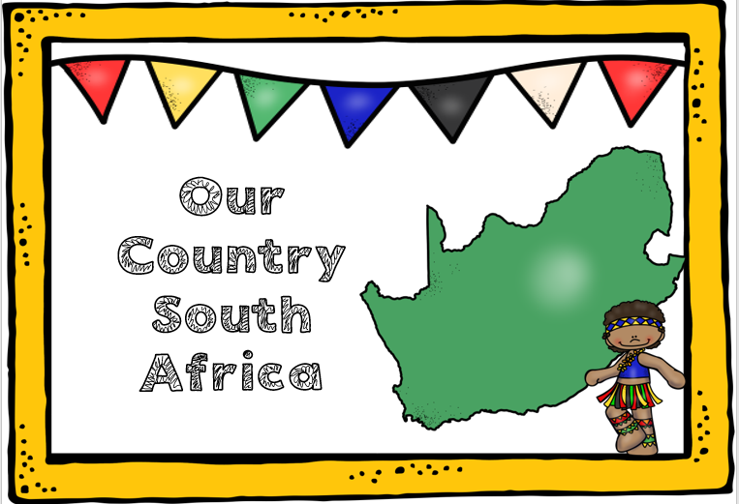

Group 1
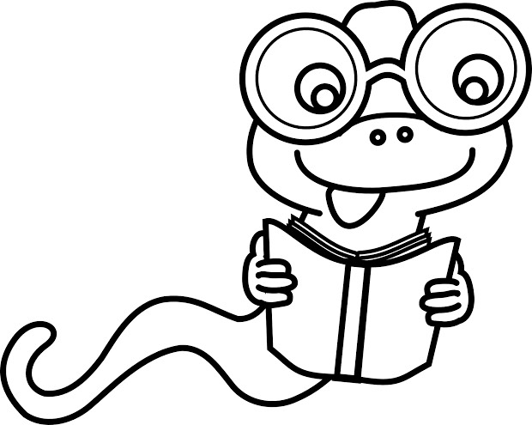

Colour the South African flag using; black, red, yellow, green, blue and white
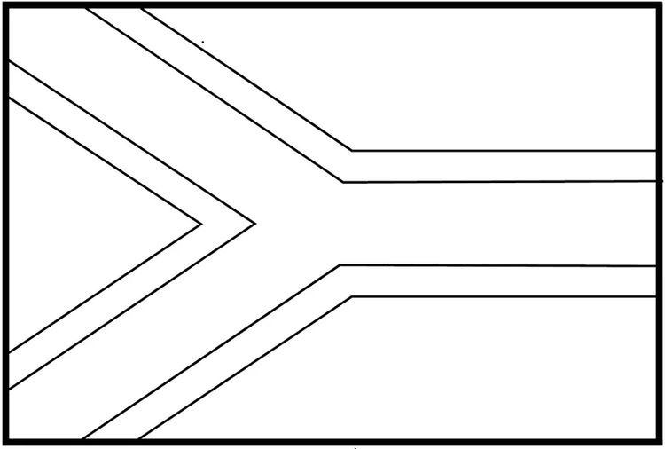

Point out 9 South African provinces
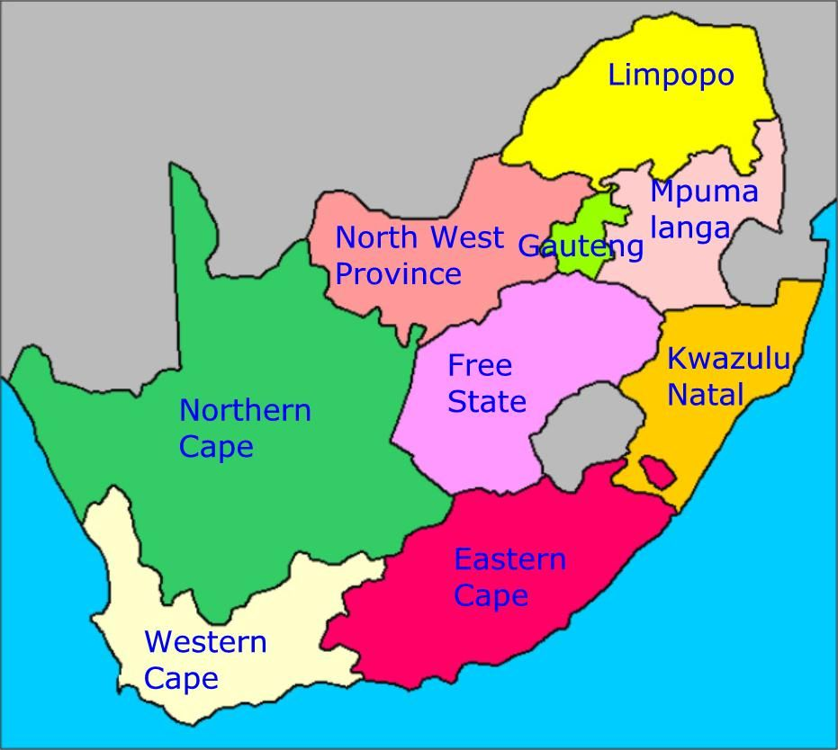

Sing the national anthem
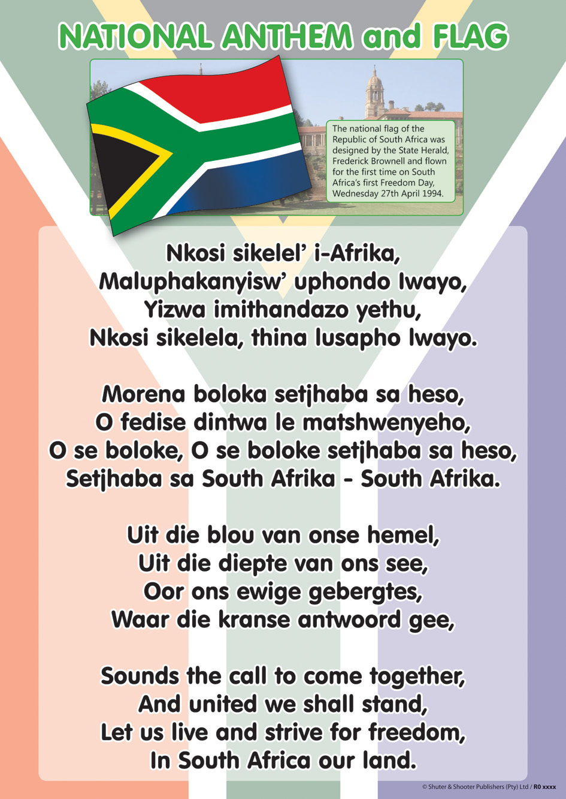
Group 2

Colour the South African flag using; black, red, yellow, green, blue and white

Colour 9 South African provinces
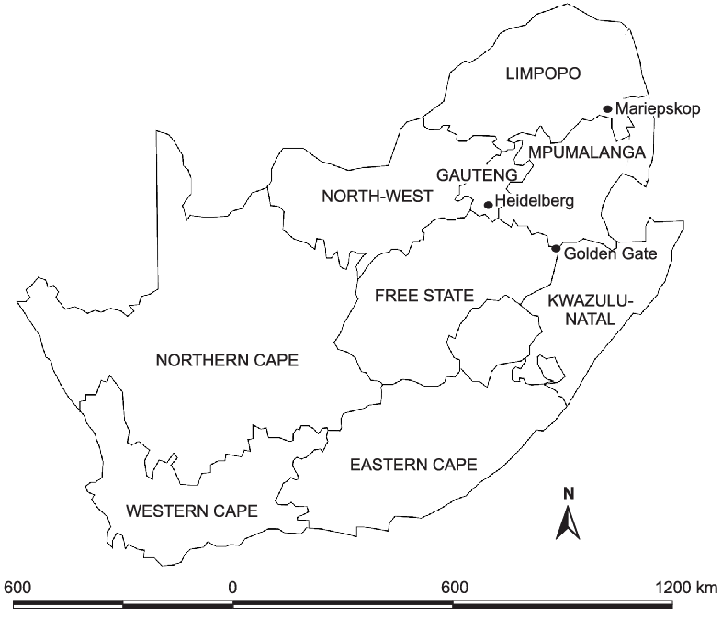

Colour in the national springbok

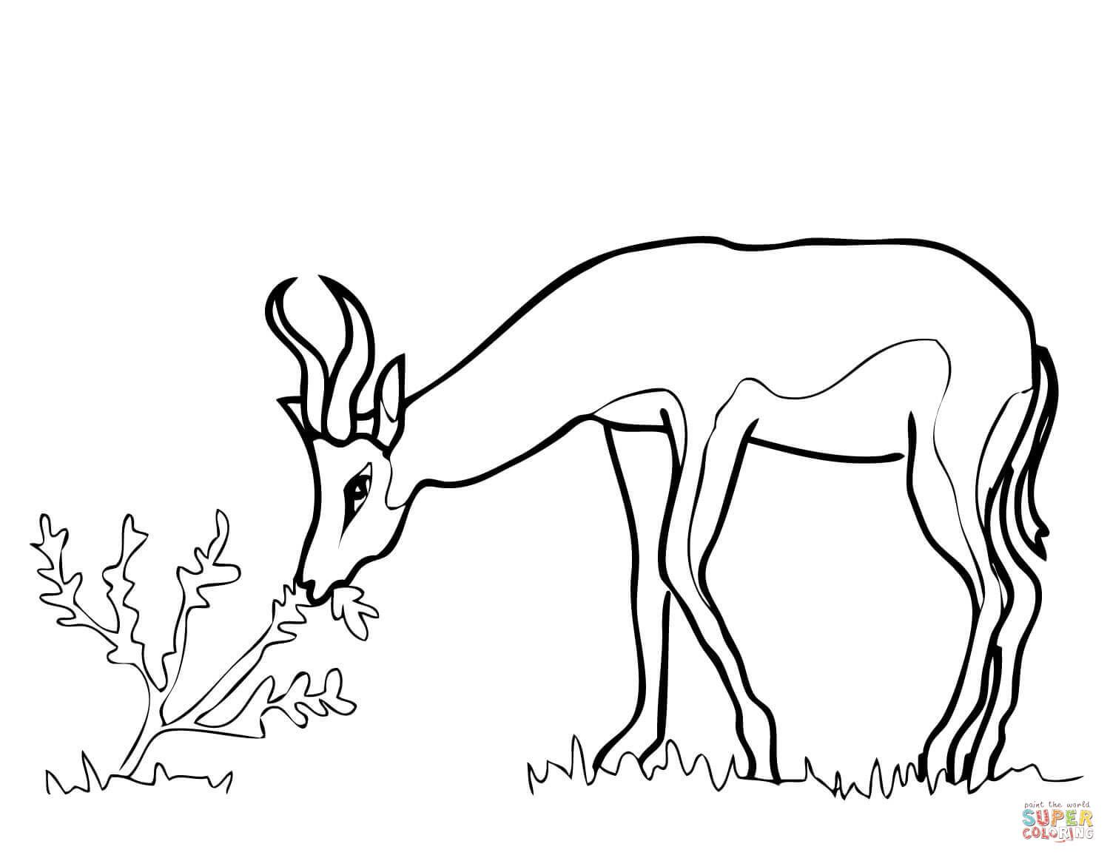

Group 3

Colour the South African flag using; black, red, yellow, green, blue and white

Colour in the protea national flower using different colours.
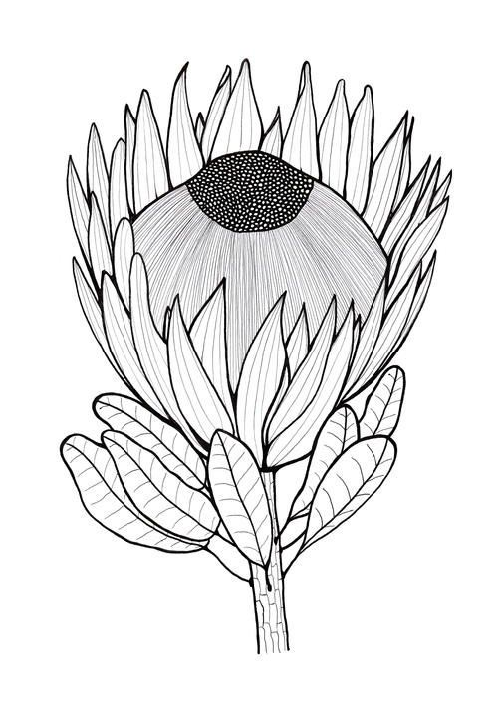
Practical work
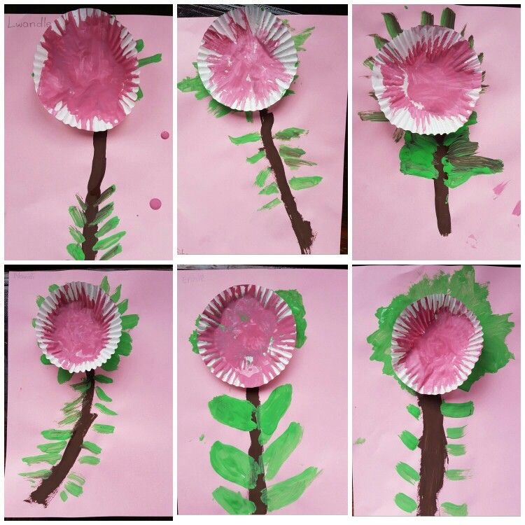

South african Map
Complete and colour the map
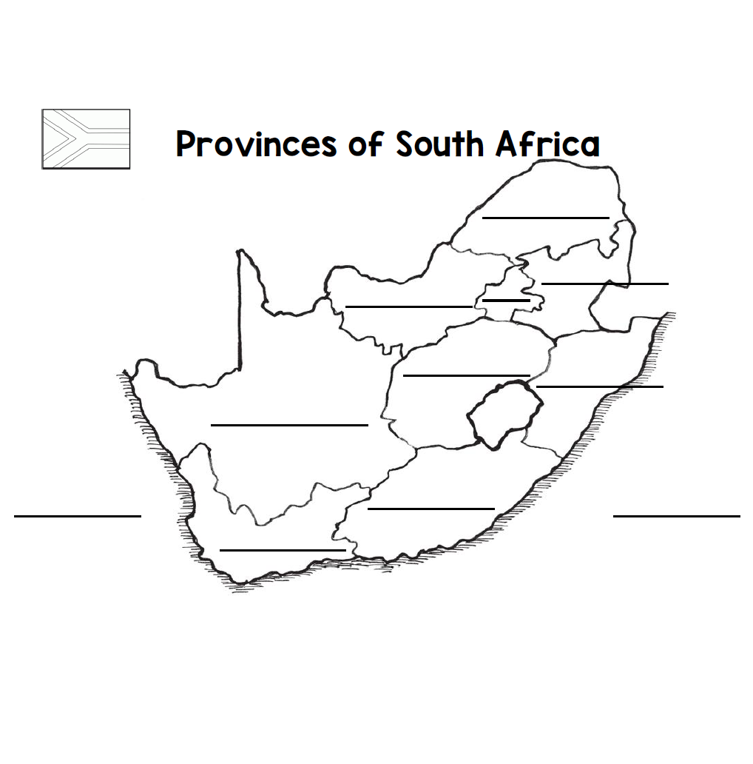

Theme
Communication in our world
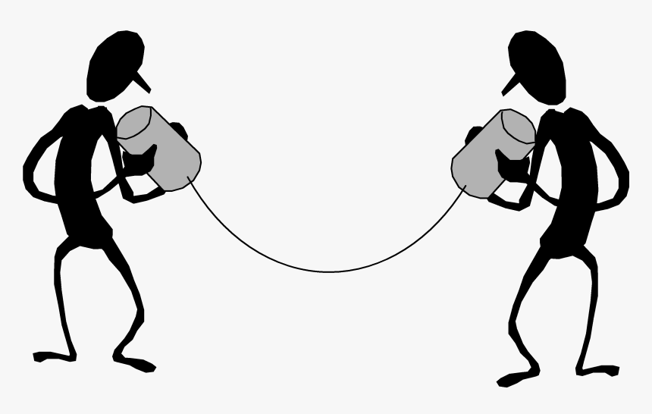
Introduction What is communication?

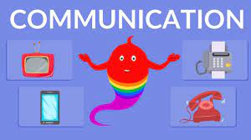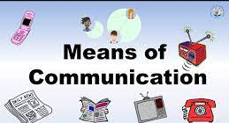
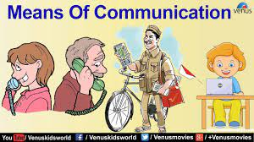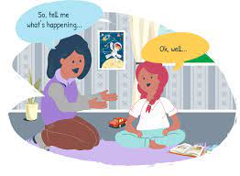
Group 1

Colour in the telephone picture


Colour in the picture below
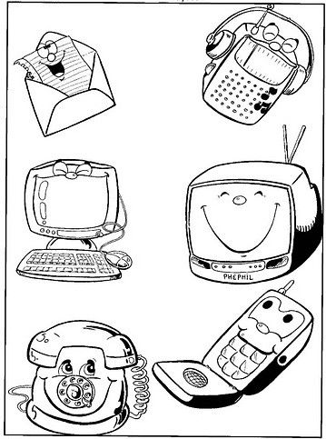
Group 2

Tick the correct form of communication tgat is used now
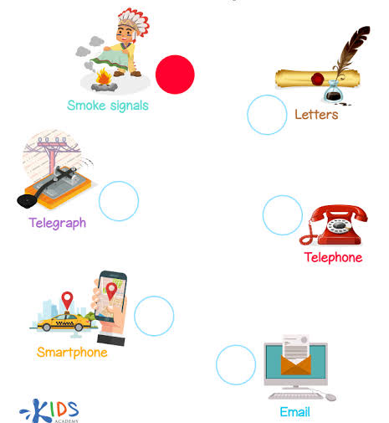

Colour in the correct forms of communication

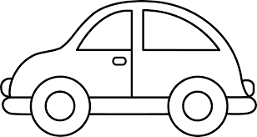
- 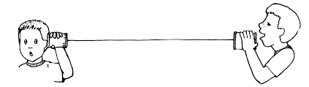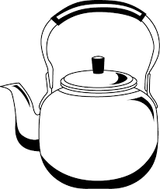

Colour in the mail communication picture below
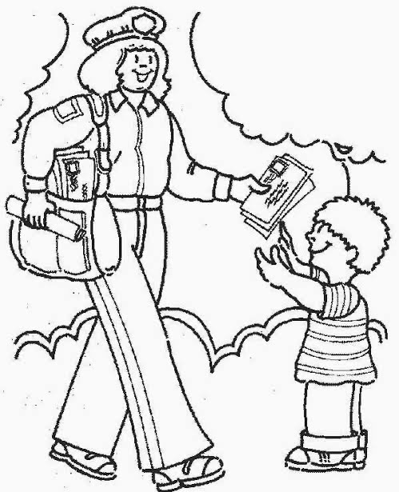
Group 3

Draw any technology gadget that is used for communication

Colour in the picture of verbal communication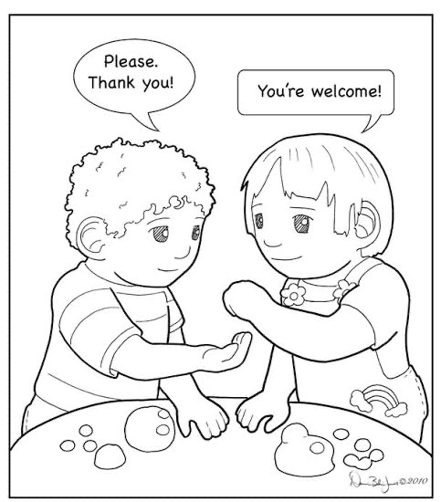

Circle the object that we use to communicate
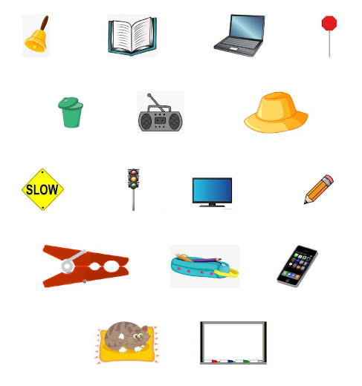

Draw lines to connect the pictures and matching communication tools
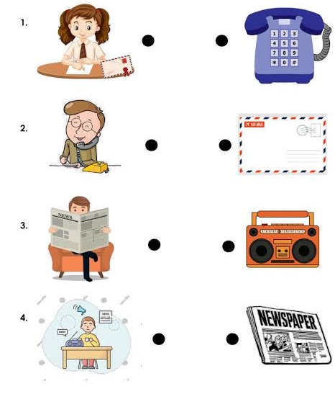
Theme
Life at night
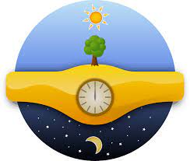
Group 1

Colour in the moon below
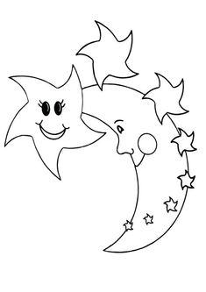

Colour in the star picture below


Group 2

Colour in the moon picture below
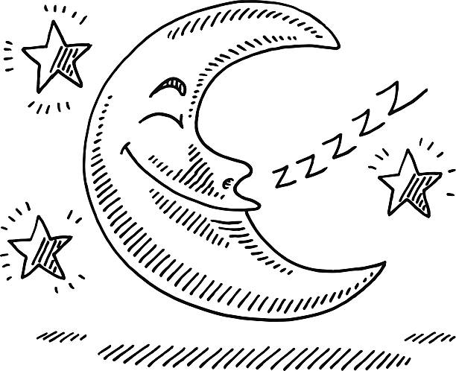

Trace and colour in the moon picture below
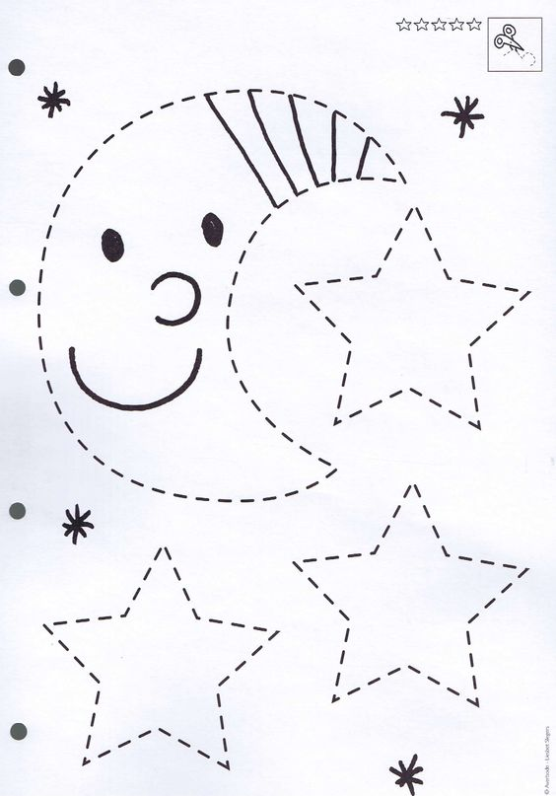
Tick the correct box of what we see at night and during the day
day night
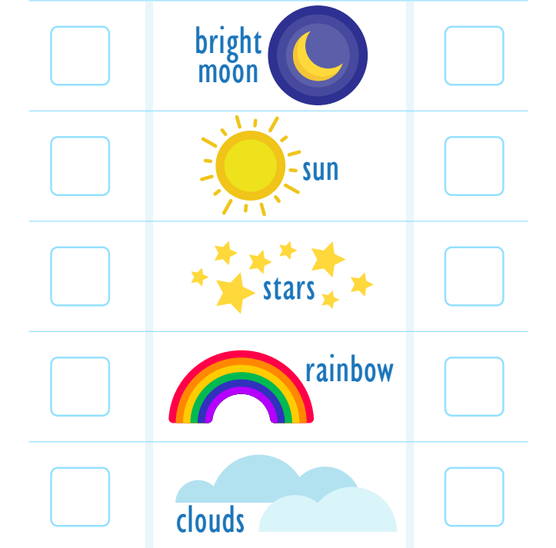
Group 3

Draw and colour in any image that represents the night

Colour the images that represent night life
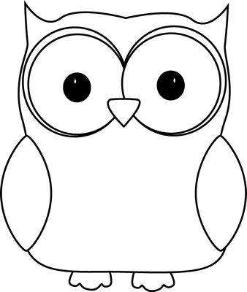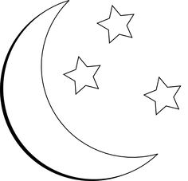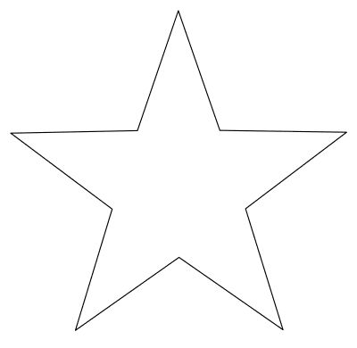
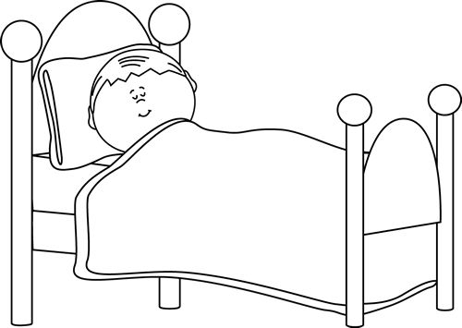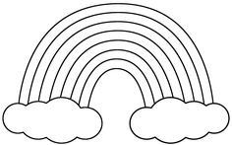
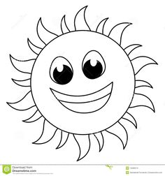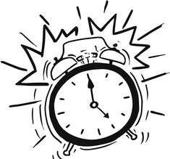
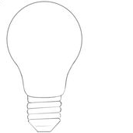
Tick$√$ the correct picture of night time

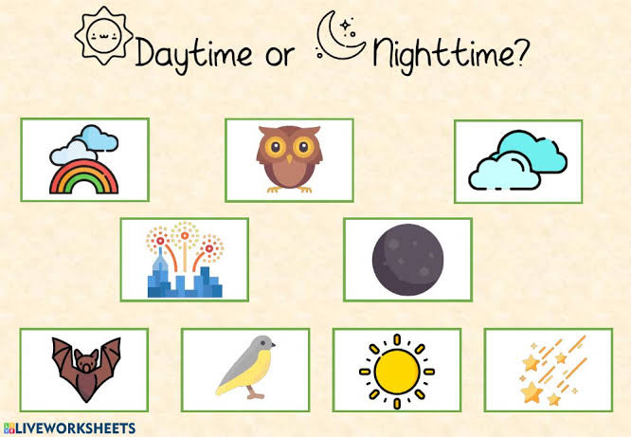

Reference list

